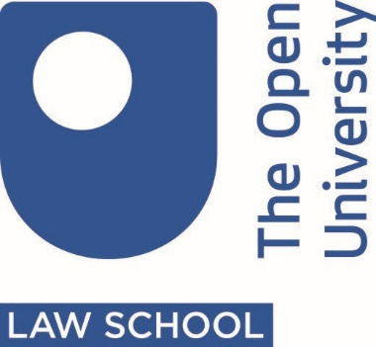

Why should law students get involved in Street Law?

What is Street Law?
Street Law is one form of public legal education (PLE). The premise underpinning PLE is that students provide legal information to members of the community. By giving people even just a basic understanding of their legal rights and duties, including the way the legal system works and how to access legal advice, they will be better able to identify and resolve the legal problems they may encounter now or in the future.
PLE is therefore an important aspect of pro bono activity and relies on core legal skills: the ability to research and communicate complex legal ideas in a way that can be easily understood by a lay audience. In this project this is likely to be teenagers.
So, by participating in Street Law you will be engaging in worthwhile pro bono projects and, in doing so, you will be developing important professional and transferable skills.

What is the Street Law Project?
The Street Law project is run in partnership with the Open University’s Open Justice Centre and the OU Law Society. It offers public legal education ‘Street Law’ workshops in secondary schools and community groups with the aim of promoting a greater understanding of law and legal issues. Through the interactive workshops, audiences engage on legal issues that are of particular relevance to them through a range of activities. Relevant legal issues could include human rights, cyberbullying, knife crime, miscarriages of justice or issues on consent.
This project could be for you if:
- You have a connection with a local secondary school or community group which would like to host a Street Law workshop, and / or
- You would like to participate in facilitating a Street Law workshop with a small group of law students

So, if you...
- Are a current aw student or alumni or a member of the OULS
- Are interested in pro bono work
- Have a connection with a local school or group or want to take part in a workshop ( we can help to locate a school for you if needed)
Then we want YOU to apply!

How will you benefit from taking part?
Taking part in a Street Law workshop is lot of fun and really rewarding. You will have the opportunity of applying your legal knowledge and skills in a way that furthers the OU’s social justice mission. It also offers you the opportunity to improve your skills and enhance your experiences and CV. Most of the students involved in Street Law have described their experience in participating in a pro bono project as being truly transformative.
I have always thought that by volunteering I could make a difference to someone else’s life, but I never thought that volunteering would give my life more meaning. I have become more confident in different aspects of my life and have developed personal and professional skills. The value of … the Open Justice activities has been … beyond my expectation. (2019 Open Justice project student).

How the OULS and Open Justice can help...?
- Support for you in communicating with your local school or community group,
- Placing you with a small group of students to facilitate and deliver the workshop
- Providing you with written guidance and resources, as well as the experience of students who have already taken part in a street law workshop
- Providing support from a tutor to plan and develop a successful presentation.
Students are usually expected to meet any travelling costs themselves. However the Open Justice Centre has a bursary scheme which can help reimburse traveling expenses in cases of hardship where this would prevent the student from taking part in the project. If you would like to find out more about this, please email open-justice@open.ac.uk

How do I get involved?
Please complete the online form which you can find on either the Open Justice website or the OU Law Society website. We will then get in touch with you.

